**Smart Augment Reality in Agricultural Production**

AR could also offer significant support to agricultural producers and farmers to accomplish their every-day tasks as well as train and strategically plan their businesses. The global population is growing exponentially resulting to a vast increase of the demand, among other resources, for food and agricultural products. Farmers will have to double their production rates. New technologies could aid farmers in achieving their goals.

**Smart AR Dashboard** provides an insight into the farm details and other agronomic information that helps in real-time monitoring of the farm, perform health checks to take more optimal decisions for improved productivity, quality and sustainability of agricultural production.

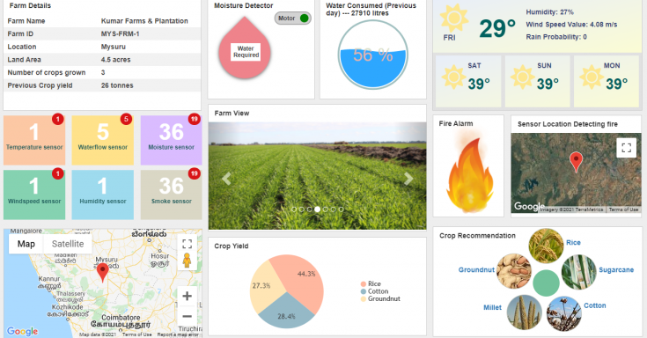

**Monitoring farms visually.**

Farmers have to check the fertility of their lands to select the most suitable crop they want to sow in the farm. AR can augment fertility inspection. With AR, farmers can visualize the entire farm in a single dashboard, monitor the overall production quality and detect the presence of any pest or insect infestation.

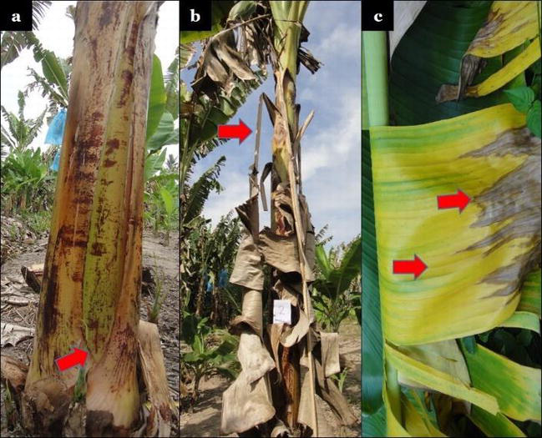

**Training new farmers.**

AR can enable new farmers to get familiar with agricultural equipment through immersive e-learning environments. AR will help new farmers to visually learn the use of complex agriculture tools minimizing at the same time serious accidents. It will also facilitate remote collaboration with and training from farmers who are experts in using advanced precision agricultural methods and techniques.

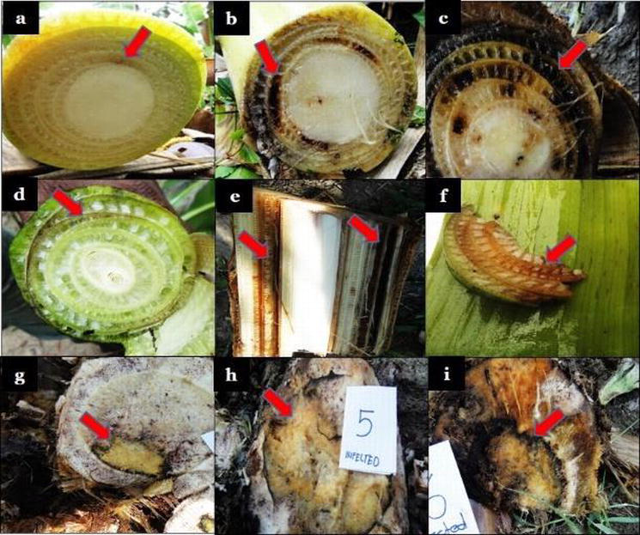

**Crop Recommendation**

Digital Farming and Precision Agriculture allow precise utilization of inputs like seed, water, pesticides, and fertilizers at the right time to the crop for maximizing productivity, quality and yields. By deploying sensors for data collection and mapping fields, farmers can understand their field in a better way conserve the resources being used and reduce adverse effects on the environment. Most of the farmers practice traditional farming patterns to decide crops to be cultivated in a field. However, the farmers do not perceive crop yield is interdependent on soil characteristics and climatic conditions. Thus, our Digital Farming solution can propose a crop recommendation system that helps farmers to decide the right crop to sow in their field based on the weather condition, moisture and season. Machine learning techniques provide an efficient framework for data-driven decision making. This Application also helps in determining the best pesticide, seed spacing and seed depth using the ML recommendation engine.

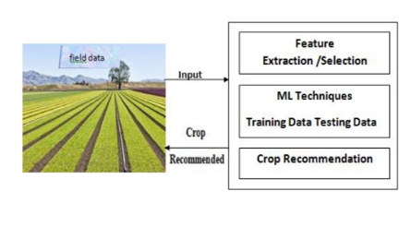

**Smart AR dashboard provides basic information about the farm like name, location land area, crops grown and other details.**

**Moisture Detector**: This section of the dashboard collects information from the moisture sensor installed at the farm and notifies regarding the water requirement at the farm at a point in time. It also depicts the status of the motor(on/off) and sends messages accordingly.

**Water Consumed**: It collects data from the water flow sensors at the farm and tells the amount of water (in liters) consumed and for irrigation the previous day.

**Weather:** This section shows the current weather conditions of the farm location that includes the Humidity (%), wind speed value and the rain probability for the day. It also displays the weather predictions for the next three days.

**Sensor Counts and Health Checks:**

 This section depicts the count and type of sensors positioned at different places of the farm and notifies regarding the count of the unhealthy sensors.

The variant of sensors installed at the farm are:

Temperature sensor,Windspeed sensor,Water flow sensor,Moisture sensor,Humidity sensor,Smoke sensor

**Farm View:** The current images of the farm and the crops grown are captured using a camera or a drone and displayed on the dashboard for inspection of quality.

**Fire Alarm and Location**: it warns if any part of the farm has caught fire detected using the smoke sensors placed in the farm and plays an alarm sound on detection, sends the coordinates for a quick response. Also, an alert gets triggered that sends an SMS on mobile to notify the farmer regarding the fire.

**Farm Location**: This section of the dashboard shows the location of the farm on the map.

**Crop Yield:** The chart depicts the percentage of the crops currently grown on the farm.

**Crop Recommendation**: It shows the crop recommendations provided by the system based on data analyzed using AI and ML algorithms based on the demographic, agricultural and market profiles.

